Call for proposals for innovative education in 2015

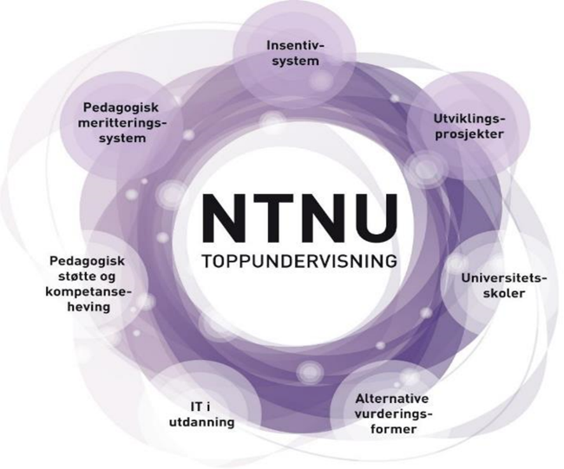
NTNU Teaching Excellence is an integrated and wide-ranging initiative aimed at helping NTNU to achieve its goal of providing education characterized by quality at a high international level. The initiative consists of a portfolio of development measures (see the figure), which together are intended to strengthen teaching skills by developing innovative teaching, learning and assessment practices. The aim of the measures is to improve students’ learning outcomes.

As part of this initiative, the Rector, with the Education Committee as advisory body, has announced funding of NOK 4 million for development projects to try out forms of teaching and/or assessment aimed at improving students’ learning outcomes and completion rate. The announcement is closely linked with two of the subprojects: Development Projects and Alternative Forms of Assessment. NTNU wants to develop quality in the assessment of students’ competence by promoting the use of forms of assessment that contribute to learning and match the learning objectives of the programme or course. Projects to develop alternative forms of assessment are therefore desirable.
New forms of teaching and assessment must be planned in relation to NTNU’s annual cycle for work with curricula. It is possible to apply for funding for two types of projects: to develop forms of teaching and/or assessment that can be tested in the context of existing course descriptions for 2015/2016, and to plan and develop schemes to be registered in Emner på Nett (EpN) in autumn 2015 for entry into force during the following academic year. (EpN is a web application for course planning on the Internet.)
All academic environments at NTNU can apply for funding for a project or feasibility study/pilot project. Each project can apply for up to NOK 250 000, and it is a prerequisite that the host faculty contributes with corresponding resources to the projects that are selected. This means that projects can have a total budget of up to NOK 500 000. The project period must be within the period August 2015 – August 2016.
Projects that receive funding are expected to document and share their experience and results so that their knowledge can be spread to many others. The development projects should help to position the academic environment in national or international collaboration and dissemination arenas for education.
Deadline for applications: 15 May 2015

Criteria for assessment of the projects:
- Relevance: How does the project address the goal of improving students’ learning outcomes and completion rate? How does the project address the academic and teaching needs that form the basis for the application? To what extent is the project innovative and grounded in empirical data and insight into how students learn? How do students contribute to the project?
- Foundation: How is the project grounded in the strategies of its own department and faculty in the area of education? Will the host faculty/department support the project with human resources/work commitment?
- Realism: Is the project feasible, given the resources, time frame and support infrastructure available? Can the solutions that the project wants to test be developed further within the normal scope of resources after the project period?
- Evaluation, sharing and collaboration: How will the results be analysed and the project evaluated? What are the plans for dissemination/publishing of knowledge and results from the project? What plans for cooperation with relevant parties are described in the application?

Assessment committee:
Roger Midtstraum (chair of the Executive Committee for Engineering Education – FUS)
John Brumo (chair of the Executive Committee for Teacher Education – FUL)
Hilde Grimstad (Vice-Dean for Education, Faculty of Medicine)
Reidar Lyng (Head of the Unit for Research in Higher Educational Training for University Staff – Uniped)
Inge Fottland (Director of the Student and Academic Division)
Student appointed by the Student Parliament
External representative

Secretary: Christina Jenkins Slutås (Senior Adviser in Rector education staff)

Timetable from the announcement to the allocation of funding:
- Call for proposals published via Innsida to all employees on Wednesday 25 March 2015.
- 15 May is the deadline for submission of applications to your own faculty.
- 29 May is the faculties’ deadline for giving priority to a maximum of 5 applications from the faculty for further consideration. It is a prerequisite that the faculties contribute resources matching the total application amount for the faculty’s project or projects to which Rector allocates funding.
- The assessment committee evaluates the applications that have been given priority by the faculties and recommends the projects that it believes should be allocated project funding. The committee’s deadline is Monday 15 June.
- The assessment committee’s proposal is submitted to the Education Committee on 24 June.
- On the basis of the committee’s recommendations and input from the Education Committee on 24 June, the Rectorate decides which applications will receive funding on about 30 June.
- Responses to applications will be given on about 1 July.
- Letters of allocation from Rector will be sent to the selected projects before 15 August.

