Solution and grading guidelines to Final SOK2007 Development Economics, NTNU

Question 1, 10 points, PS2, Q4
Unconditional convergence is the theory of countries’ economies all converging to the same steady state of per capita income over time, regardless of their starting points and economic parameters.
The reasoning behind this theory is that lower- income countries will have higher growth rates than higher-income countries. Diminishing marginal returns from capital means that countries with less capital per worker initially can grow faster than countries with more capital per worker. Additionally, lower- income countries can use innovation and technology made from higher-income countries, not having to use its resources on research and development.
If this unconditional convergence were true, no attempts would have to be made to avoid gaps between rich and poor countries becoming larger, it would simply occur by itself. Even though studies looking at a few, handpicked countries’ growth and development over time suggest some evidence for this, larger studies unfortunately show that there is no real unambiguous relationship between initial p.c income and growth rate.
The Solow model predicts convergence for countries with the same economic parameters: equal saving rate, depreciation rate, productivity, population growth, etc. Two countries with these same parameters, but with different starting points of capital and production per capita, would converge over time, due to the increase in capital and production per worker for each period would be larger for the country with lower income. Graphically, we can think of this as the countries having the exact same production function, savings/investment function and depreciation function, but starting at different points along the same functions. No matter the initial level of capital and production, the countries would have the same long-term steady state, giving convergence over time. This is conditional convergence, convergence conditional on having the same economic parameters.
Comparing unconditional convergence to the convergence predicted in the Solow model: for instance, if two countries start in the same point of capita and production per worker can grow in opposite directions, due to their differences in the rate of investment. Unconditional convergence would have given the same steady-state level for both countries over time, but in the Solow model the countries move towards different steady states. This shows us that the Solow model does not predict unconditional convergence.
[Full points should be given for correct description of unconditional and conditional convergence concepts plus illustrating some empirical evidence about the two theories, regardless of the length of the answer. Lengthy answers that do not make sense should not get full points.]
Question 2, 25 points, PS4, Q1

Part 1 [15 points]
As mentioned in the question, we will assume throughout that $α=1/3$. In order to calculate the growth rate of factor endowments (i.e., factor accumulation) for each country, we can utilize the following equation.

$$\text{Factor accumulation, }\hat{F}=α\hat{k}+\left(1-α\right)\hat{h}$$

In this equation, the growth rate of physical capital per worker, $\hat{k}$, and the growth rate of human capital per worker, $\hat{h}$, are already given for each country. Next, in order to calculate the growth rate of productivity for each country, we can utilize the following equation.

$$\text{Growth rate of productivity, }\hat{A}=\hat{y}-\hat{F}=\hat{y}-\left[α\hat{k}+\left(1-α\right)\hat{h}\right]$$

The second term in this equation (in square brackets) is the previously calculated growth rate of factor endowments. Moreover, the growth rate of output per worker, $\hat{y}$, is also already given for each country. The results from both of these calculations for each country are provided in the 4th and 5th columns of the table below (the first 3 columns simply replicate the data already provided in the question).

Country | Growth Rate of Output per Worker, $\hat{y}$ | Growth Rate of Physical Capital per Worker, $\hat{k}$ | Growth Rate of Human Capital per Worker, $\hat{h}$ | Growth Rate of Factor Inputs per Worker, $\hat{F}$ | Growth Rate of Produc-tivity per Worker, $\hat{A}$
Cameroon | 0.1474 | 0.9290 | 1.1180 | 1.0550 | -0.9075
China | 7.6187 | 7.8467 | 1.1213 | 3.3631 | 4.2557
Luxembourg | 3.4987 | 2.7437 | 0.2885 | 1.1069 | 2.3919
Sri Lanka | 3.5788 | 2.8291 | 0.4136 | 1.2188 | 2.3600

Part 2 [5 points]
For Cameroon, where productivity growth has been negative, it is difficult to objectively assess whether factor accumulation or productivity growth has contributed more to its output growth. It could be argued that in this country, factor accumulation has been more important, since it has at least partly offset the detrimental influence of negative productivity growth on output growth.

For the other countries, however, it is possible to compare the ratio of factor accumulation to output growth with the ratio of productivity growth to output growth. In China, for instance, factor accumulation accounts for 44% of output growth, and this same ratio is 34% for Sri Lanka and 32% for Luxembourg.

Part 3 [5 points]
On the other hand, in Luxembourg, productivity growth accounts for 68% of the output growth, in comparison to 66% for Sri Lanka and 55% for China. Thus, it can be argued that in this set of three countries, factor accumulation contributes the most to output growth in China, whereas productivity growth contributes the most to output growth in Luxembourg.

[Full points should be given for providing the correct reasons and steps for answering part 2 and 3. Answers without clear reasons should be given partial credit. Partial credit can be given if the calculation from part 1 is wrong but with right formula.]

Question 3, 20 points, PS4, Q4

Part 1 [15 points]
The first step is to rewrite the aggregate production function, given by $Y={\left(AK\right)}^{α}L^{1-α}$, into the following term: $Y=K^{α}{\left(eL\right)}^{1-α}$. This requires $A^{α}{=e}^{1-α}$ , which gives ${e=A}^{α/(1-α)}$.

In per effective worker terms:
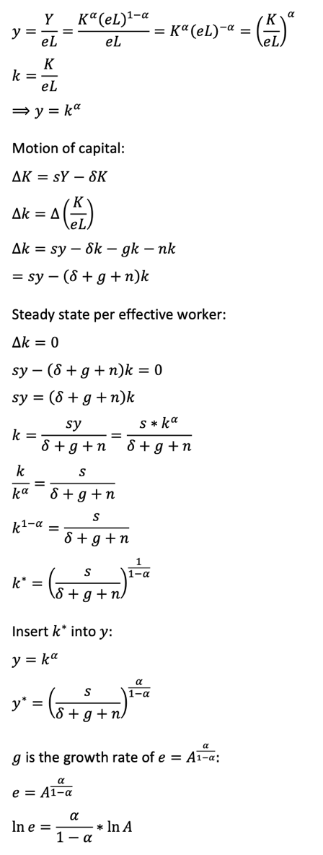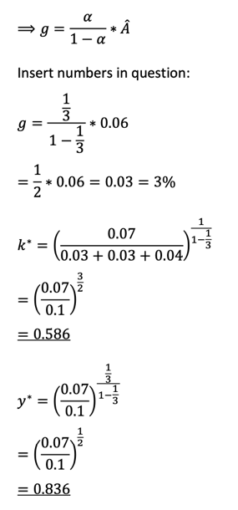

Part 2 [5 points]
In the steady state, the growth rate of output per worker is equal to the rate of technological growth e, whose growth rate is g. This is also the long-run growth rate in standard of living.
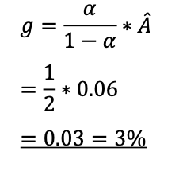
[Partial points given for wrong calculation but with the right derivation and formula. If wrong answer obtained for the key derivation ${e=A}^{α/(1-α)}$ since part 1, then at most 10 out of 20 points can be given for the whole question.]

Question 4, 15 points, PS1, Q5

Part 1 [5 points]
Similarities:
Like for other factors, it is possible to allocate resources and manpower towards bettering technology. Technological advancement can only happen through not allocating all of the economy’s resources to investing in new capital or investing in human capital. This is done by making investments in research and development (R&D). Investing in R&D means there will be some forgone consumption in the present, to hopefully increase productivity enough for consumption in the future to be greater.

Differences:
Technology is not a production factor per se, more a factor to improve production factors, usually capital. This gives technology some different properties from the regular production factors. Since development of technology means that it is available for many to use at the same time, technology is non-rival in its use. This differs from production factors like labour and capital, a worker operating an excavator cannot be used in multiple places simultaneously while doing a full job. The technology behind the machine, however, can be taken use of at the same time in many places around the world.

Technology also has a low or a non-level of excludability. Where the owner of a machine can prevent others from using it, it is difficult to prevent others from using technology. Both points above show that there are some positive social externalities from R&D of technology. Many can benefit from technological advancement at the same time.

Part 2 [5 points]
A problem with the positive social externalities associated with technological progress is that the non-excludability makes it difficult for developers of the technology to get a return on their investment. We have seen that R&D in technology is an investment like in other factors, meaning that some level of standard of living is forgone to get a higher standard of living later. On a private level, if developing a technology results in everyone having the chance to copy and use it right away, there will be no or little income/return going to the developer. If there is no compensation for the risk of the investment, there is a reduced or no private incentive for the developer to make the investment in the first place, and society ends up with few or no new inventions.

Part 3 [5 points]
To make sure there is a private incentive for R&D of new technology, governments can enact policies of patents and similar grants. Receiving a patent on a new invention means that the creator has the sole right to it, being able to make, use, and sell it for a given period of time. In this time period, the developer is assured of the eventual return and income from this exact technology, which increases the private incentive to develop new technologies.

By offering patents, the government essentially allows a form of monopoly for a period of time, since the social benefits from new inventions outweigh the market efficiency loss. Either way, without any form of patents or the like, there would have been no social benefits to reap in the future, due to a lack of new inventions.

[Full points should be given for answering the key points, regardless of the length of the answer.]

Question 5, 10 points, PS4, Q4

Part 1 [5 points]
The Kuznets curve is drawn in a graph with income per capita on the x-axis, and measure of inequality on the y-axis. The curve suggests that economic growth has a different impact on the inequality, depending on the starting income per capita. Starting from low levels of income p.c, inequality increases with increasing income, whereas at higher levels of income p.c, inequality decreases with increasing income. [The figure is not mandatory if the answer explains well the curve.]
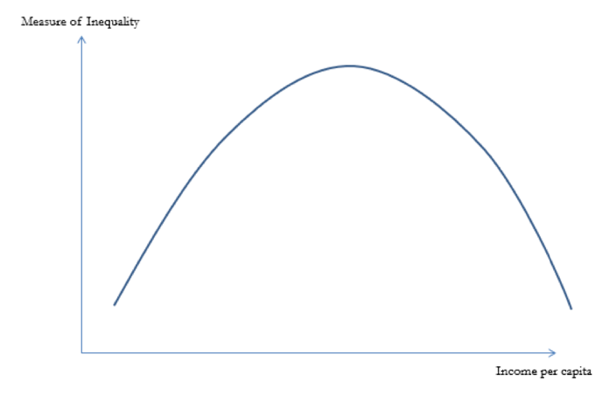
A theory behind this suggested relationship is that initial economic growth would not be spread equally among the population. As a country transitions from predominantly agriculture to developing some other sector, for instance manufacturing, incomes would rise faster in the new and more profitable sector. Initially, some part of the population experiences the benefits of the economic growth, while others do not, resulting in greater inequality.
After a while, other sectors would catch up, giving increased income here, and inequality eventually decreases. Multiplier effects from higher national income gives greater demand for other goods and services. Policies aiming to redistribute income may also be introduced, giving further decreased inequality.
Part 2 [5 points]
If we follow the Kuznets curve, increasing inequality for developing countries facing economic growth might be expected and natural. Some sectors could have higher growth than others, giving higher increases in income for some than others, ending up with greater inequality. A reason to not be concerned about the increasing inequality could be that as the economic growth continues, the Kuznets curve expects inequality to decrease for higher levels of per capita income.
It should be noted that the decreasing inequality is not necessarily a natural cause from further increasing per capita income, the Kuznets curve is based on empirical data from countries. Policies for income redistribution may be an important part of the decreasing inequality, which would not happen by itself. Also, the Kuznets curve states that the increasing income per capita leads to higher and then lower levels of inequality, it does not suggest that higher or lower levels of inequality necessarily leads to some unambiguous effect on economic growth.
Question 6, 20 points, PS4, Q3
Part 1 [5 points]
The given parameters of the model are: $L=1$, $μ=5$, and $γ_{A}=0.5$. To calculate the initial growth rate of output per worker, we substitute these values into the relevant equation of the model for the growth rate of productivity as follows.

$$\hat{y}=\hat{A}=\frac{γ_{A}L}{μ}=\frac{0.5}{5}=0.1$$
Thus, the initial growth rate of output per worker is 10% per annum.

Part 2 [15 points]

Similarly, after the increase in $γ_{A}$ to 0.75, the growth rate of output per worker will be the following.

$$\hat{y}'=\hat{A}'=\frac{γ_{A}'L}{μ}=\frac{0.75}{5}=0.15$$
In this case, output per worker will grow at 15% per annum. Recall, however, that just after the increase in $γ_{A}$, the level of output per worker will have dropped (due to the reduction in labor allocation to the production of final goods).

Let $A$ denote the level of productivity at the time of the increase in $γ_{A}$. The level of output per worker just prior to the drop can then be expressed in terms of $A$, by substituting the initial set of parameter values into the per-worker production function.

$$y=A\left(1-γ_{A}\right)=A\left(1-0.5\right)=0.5A$$

Now, since we do not expect the level of productivity to change instantaneously after the increase in $γ_{A}$, the level of output per worker just after this increase can be similarly expressed as follows.

$$y'=A\left(1-γ_{A}'\right)=A\left(1-0.75\right)=0.25A$$

Let $t$ be the number of years it takes after the increase in $γ_{A}$ for output per worker to recover to the level it would have been had there not been any change in $γ_{A}$. Given that under the original value of $γ_{A}=0.5$, output per worker would have grown at a rate of 10% per annum, then after $t$ years, the counterfactual level of output per worker would have been $0.5A{(1+0.1)}^{t}$. We need to find how long it will take to reach this counterfactual level of output per worker, starting from a level of $0.25A$ and with a growth rate of 15% per annum. In other words, we need to solve for $t$ in the following equation.

$$0.25A{(1+0.15)}^{t}=0.5A{(1+0.1)}^{t}$$

Collecting the terms with $t$ as exponent on one side and the remaining terms on the other, this equation simplifies to the following.

$${\left[\frac{1.15}{1.10}\right]}^{t}=\frac{0.50A}{0.25A}=2$$

Then, taking natural logs on both sides, we get the following.

$$t\text{ ln}\left[\frac{1.15}{1.10}\right]=\text{ ln} [2]$$

Finally, solving the above equation for $t$ yields the following.

$$t=\frac{\text{ln} [2]}{\text{ln }[1.15/1.10]}=15.59$$

Thus, after the increase in $γ_{A}$, it will take approximately fifteen-and-a-half years for the level of output per worker to recover to the level at which it would have been had there not been such a change in the allocation of the labor force to R&D. §

[Partial credit is given to correct reasoning but with wrong calculations.]

