Answer manual – SØK2011

Disclaimer: This document is a possible way to answer the questions, in some cases other type answer can be correct.
The points for each question are indications and might be subject to marginal changes.

Task 1 – 40 points
Part A – 17 points
1. – 2 points
Rewrite supply and demand curves in terms of price:
Demand: $Q_{d}=- \frac{500}{3} P + \frac{25000}{3}$ $P = 50 - 0.006Q_{D}$
Supply: $Q_{s}= 500P$ $P = 1/500 Q_{S}=0.002Q_{S}$
Equilibrium of the market when supply is equal to demand:
$0.002Q$ = $50 - 0.006Q$ $Q= 6250$
Replace Q in supply equation to get P:
$$P=0.002× 6250 = 12.5$$
Solution: P = 12.5 and Q=6250

2. – 5 points
t=10
The demand curve becomes:
$$P + t= 50 - 0.006Q_{D}$$
$$P + 10= 50 - 0.006Q_{D} P = 40 - 0.006Q_{D}$$

From the equality of new demand curve and supply curve we get the new quantity on the market:
$0.002Q$ = $40 - 0.006Q$ $Q= 5000$
We replace Q in the supply curve to get the producer price ($P_{S})$:
$$P_{S}=0.002× 5000 = 10$$
The consumer price ($P_{D})$ is $P_{D} = P_{S} + t = 10 + 10 = 20$
The quantities on the market decreased from 6250 to 5000.
The consumer price increased from 12.5 to 20, i.e. (20-12.5)/100 = 60%

3. – 10 points
Indications for explanation:
The deadweight loss comes from a loss of consumer and producer surplus that is not compensated by the tax revenues.
This is due to the change in relative prices that is induced by the tax and the substitution effect. Can also explain in terms of externality.

Graph:
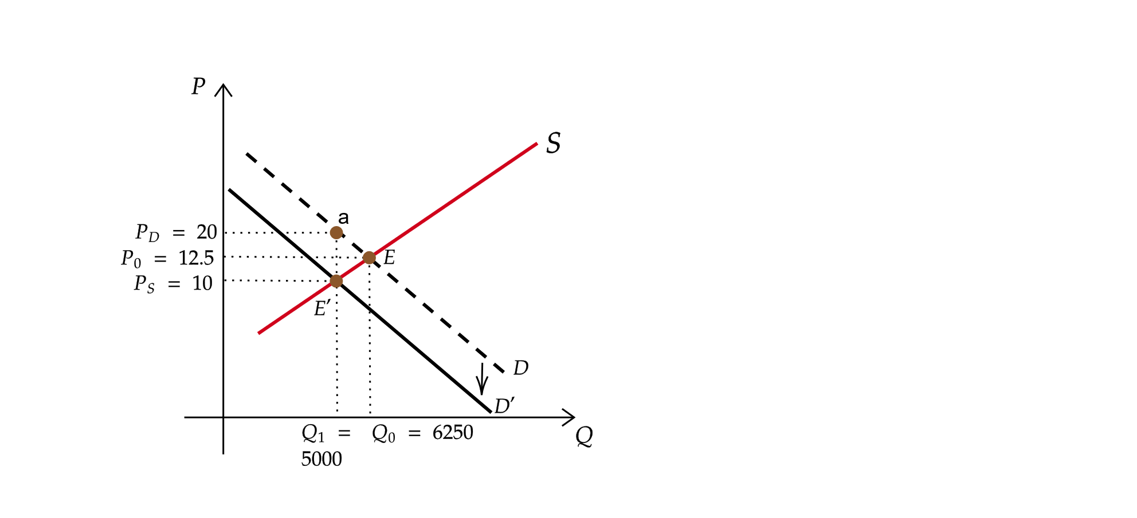
The deadweight loss is the triangle aEE’

Part B - 23 points
4. – 2 points

The price elasticity of D = % change in quantity demanded / % change in price
For Type A: A 1% change of the price of alcohol lead to a decrease of the quantity consumed of 0.08.

5. – 8 points

Note: The true price change in part A is 60%, if 60% is used as the percentage change in price the calculations are considered correct.

% change in quantity = price elasticity of D x % change in price
% change in price is always 62.5%
For Type A: % change in quantity = - 0.08 x 62.5% = -5%, ie -5% x 20 = -1 so new quantity= 20 – 1 = 19
For Type B: % change in quantity = - 0.16 x 62.5% = -10%, ie -10% x 20 = -2 so new quantity= 20 – 2 = 18
For Type C: % change in quantity = - 0.24 x 62.5% = -15%, ie -15% x 20 = -3 so new quantity= 20 – 3 = 17
For Type D: % change in quantity = - 0.32 x 62.5% = -20%, ie -20% x 20 = -4 so new quantity= 20 – 4 = 16

For Type A: % change in quantity = - 0.08 x 60% = -4.8%, ie -4.8% x 20 = -0.96 so new quantity= 20 – 0.96 = 19.04
For Type B: % change in quantity = - 0.16 x 60% = -9.6%, ie -9.6% x 20 = -1.92 so new quantity= 20 – 1.92= 18.08
For Type C: % change in quantity = - 0.24 x 60% = -14.4%, ie -14.4% x 20 = -2.88 so new quantity= 20 – 2.88 = 17.12
For Type D: % change in quantity = - 0.32 x 60% = -19.2%, ie -19.2% x 20 = -3.84 so new quantity= 20 – 3.84 = 16.16

The consumer that is the most impact is the type D because it has the highest elasticity.

6. – 3 points
Tax paid: quantity consumed x amount of the tax (10)
Type A= 19x10 = 190
Type B= 18x10 = 180
Type C= 17x10 = 170
Type D= 16x10 = 160

If calculations with a 60% change
Type A= 19.04x10 = 190.4
Type B= 18.08x10 = 180.8
Type C= 17.12x10 = 171.2
Type D= 16.16x10 = 161.6

7. – 10 points
Average tax rate = T/I
Tax paid (T) | Income (I) | Share of income (T/I)
190 | 10000 | 1.9
180 | 20000 | 0.9
170 | 50000 | 0.34
160 | 100000 | 0.16

If use of 60% change in price:
Tax paid | income | share of income
190.4 | 10000 | 1.9
180.8 | 20000 | 0.9
171.2 | 50000 | 0.34
161.6 | 100000 | 0.16

The average tax rate decreases with income. We have a regressive tax. This comes from the fact that even if the initial consumption is the same for everyone, the price elasticity is different and is lower, the lower the income. These individuals adjust less their consumption in response to the taxation of alcohol.
What can wonder whether this is fair: the burden of the tax is higher for low-income individual.
Task 2 – 25 points

1. 4 points
$$Max U(I,L) = I + 400 ln(L) given I = w(T-L)$$
where w=25 and T=60

Lagrange function:
$$F = I + 400 ln (L) - (I - w(T-L))$$
$$\overset{⇒}{} F = 400 ln (L) + w(T-L)$$
First order condition of Lagrange function:
$$\frac{∂F}{∂L} = 400 × \frac{1}{L} - w = 400 × \frac{1}{L} - 25 = 0$$
$$\overset{⇒}{} L = 400/25 = 16$$
So number of worked hours: T – L = 60 – 16 = 44

2. 9 points
$$Max U(I,L) = I + 400 ln(L) given I = w(1-t)(T-L)$$
Lagrange function:
$$F = I + 400 ln (L) - (I - w(1-t)(T-L))$$
$$\overset{⇒}{} F = 400 ln (L) + w(1-t)(T-L)$$

First order condition of Lagrange function:
$$\frac{∂F}{∂L} = 400 × \frac{1}{L} - w(1-t)= 400 × \frac{1}{L} - 25(1-t)= 0$$

We get an expression of L in terms of t:
$$\overset{⇒}{} L = \frac{400}{25(1-t)}$$
In this case t=20%, we replace in the previous expression and obtain:
$$\overset{⇒}{} L = \frac{400}{25(1-0.2)} = 20$$

So number of worked hours: T – L = 60-20 = 40
There has been a decrease in the number of worked hours.

3. - 12 points
Two effects are playing: substitution effect and income effect
Substitution effect: price of leisure is less expensive so consume more of it, tends to increase the leisure
Income effect: earn less from one working hour so need to compensate for that, tends to increase the number of working hours
In that case, the tax introduced a decrease in the number of worked hours and an increase in hours of leisure: the substitution effect dominates.

Task 3 – 25 points

- – 4 points
The total income is divided in two so each individual gets 5,000/2=2,500
To obtain the individual utility for this outcome, we replace the income by 2,500 in the two utilities functions:
Alex’s utility: $2 × \sqrt{2500 } = 2 × 50 = 100$
Bob’s utility: $4 × \sqrt{2500 } = 4 × 50 = 200$

- – 4 points
We need to solve the following system:
$$\left\{\begin{aligned}2 × \sqrt{I_{A}}= 4 × \sqrt{I_{B}} \\ 5000 = I_{A }+ I_{B }\end{aligned}\right.$$
From the second equation we can express $I_{A} = 5000 - I_{B}$. We replace in the first equation and resolve:
$$2 × \sqrt{5000 - I_{B}}= 4 × \sqrt{I_{B}}$$
$$\underset{⇔}{}\left(5000-I_{B}\right)=4I_{B}$$
$$\underset{⇔}{}5000=5I_{B}$$
$$\underset{⇔}{}1000=I_{B}$$
Then we get $I_{A}= 5000 - 1000 = 4000$

- – 4 points
Here we need to maximize the function $2 × \sqrt{I_{A}}+ 4 × \sqrt{I_{B}}$
We use the relationship $I_{A} = 5000 - I_{B}$ from before and get that we need to maximize the function $2 × \sqrt{5000 - I_{B}}+ 4 × \sqrt{I_{B}}$
The maximum is obtained when the derivative of this function is equal to zero, i.e.:
$$-\frac{1}{\sqrt{5000 - I_{B}}} + \frac{2}{\sqrt{I_{B}}}= 0$$
$$\underset{⇔}{} 5000 - I_{B} = \frac{1}{4}I_{B}$$
$$\underset{⇔}{}4000=I_{B}$$

Then we get $I_{A}= 5000 - 4000 = 1000$

- – 6 points
Possibilities: maximin criterion, additive welfare function with different weights to people.
These functions both values differently individuals, this is different from what is done with the additive social welfare function.

- – 7 points
Possible limits:
  - How to measure individual utility: these social welfare functions rely on individual utility but in practice one does not necessarily have a way to measure these utilities. One does not always know what to include in it.
  - How to aggregate the utilities, i.e how to choose the social welfare function: challenge to measure the preferences of the population to know if we should apply an additive welfare function or a maximin criterion function.

Task 4 – 10 points

- - 5 points
Table without voting paradox:
 | Group 1 | Group 2 | Group 3
First | 0 | 20 | 40
Second | 20 | 40 | 20
Third | 40 | 0 | 0
0 against 20: Group 1 versus Group 2 and 3: 20 is adopted
0 against 40: Group 1 versus Group 2 and 3: 40 is adopted
40 against 20: Group 3 versus Group 1 and Group 2: 20 is adopted
- 20 is adopted

- -5 points
The voting paradox is what happened when the outcome of the voting is inconsistent, even if the preferences are consistent.
Single-peaked preferences is the condition to not have a voting paradox.

Possible table of new preferences with a voting paradox:
 | Group 1 | Group 2 | Group 3
First | 20 | 0 | 40
Second | 0 | 40 | 20
Third | 40 | 20 | 0

0 against 20: Group 2 versus Group 1 and 3: 20 is adopted
0 against 40: Group 1 and 2 versus Group 3: 0 is adopted
40 against 20: Group 3 and Group 2 versus Group 1: 40 is adopted
- Voting paradox

