Department of Biology

Examination paper for BI3082 – Biodiversity and conservation biology II

Academic contact during examination: Irja Ida Ratikainen
Phone: 47344606

Examination date: 19.05.2017
Examination time (from-to): 09.00-13.00
Permitted examination support material: None

Other information: The percentage weight of each question for the total evaluation is marked in parenthesis.

Language: English
Number of pages (front page excluded): 1
Number of pages enclosed: 1

Informasjon om trykking av eksamensoppgave Originalen er:
1-sidig □ 2-sidig □
sort/hvit □ farger □
skal ha flervalgskjema □

Checked by:

____________________________
Date Signature

Question 1 (20%):
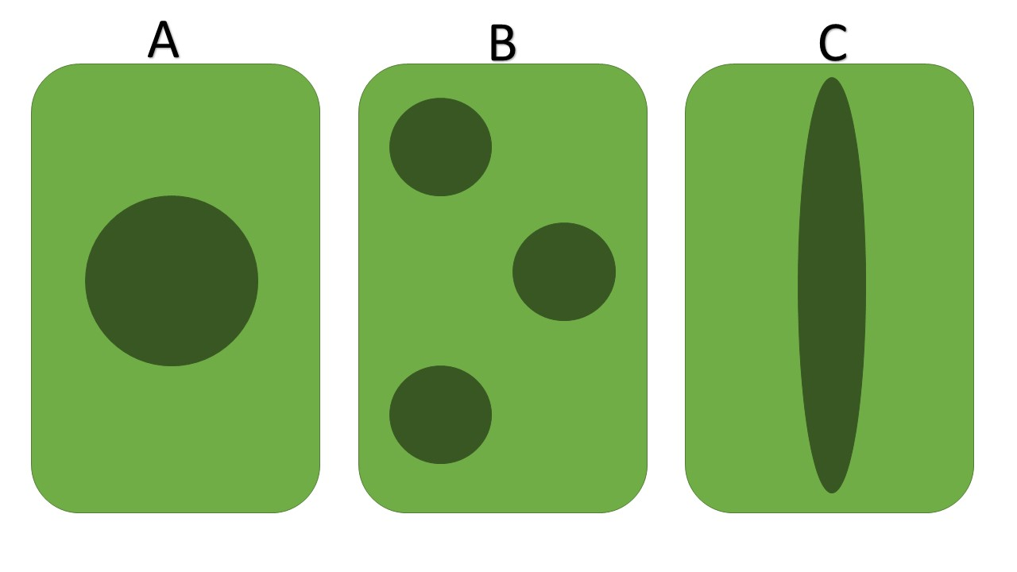
Imagine that the three figures A-C show possible shapes for Protected Areas (PAs), and that the dark green areas are PA, while the light green area is unprotected habitat. Assume that the total area protected is the same in all three cases. For each of the possible shapes (A, B and C) list three reasons why this could be a preferable shape for protection. What does this depend on?

Question 2 (20%):
What is a Minimum Viable Population (MVP) and what information is needed to determine the MVP for a species?

Question 3 (20%):
What are the different types of species interactions we can expect to find within ecosystems? Briefly describe two examples of why such species interactions may be important in conservation biology. Make sure your two examples include at least two different types of species interactions.

Question 4 (20%):
Imagine a lemur species living in a particular habitat consisting of humid forests on Madagascar. Since the 1950s deforestation has led to substantial loss of suitable habitat, and the lemur species is now present in only three habitat patches, with a small population size in each. The habitat patches are separated by mostly agricultural land, so few lemurs are able to successfully disperse between the populations.

- Explain briefly which genetic processes you expect will be important in the three remaining populations of this species, and how each of these genetic processes will affect genetic variation within and between the populations.

- Explain briefly how genetic management could be used to reduce the extinction probability of the three remaining lemur populations.

Question 5 (20%):
Explain what type of evolutionary implications different types of harvest may have on populations and how this in return may be important for conservation biology and management.

